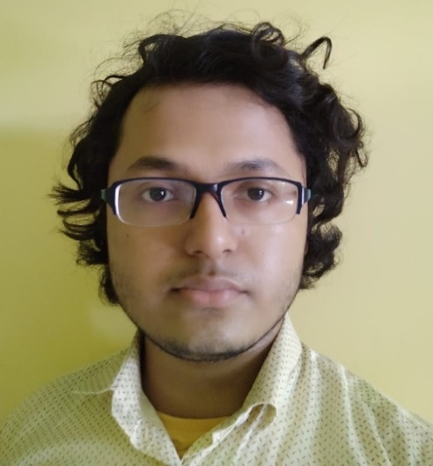

**Projects**

* Built a *Web App* to display charts, based on *real-time data* as well as *static data* collected from SharePoint Lists, Database, csv files, etc. Used *Python (Flask)* to build authentication and backend. Used *Python (Pandas)* and *SQL* for *Data Analysis*, the modified data is stored as a *JSON* object, in an *API*. Used *JS library Chart JS* for *Data Visualization*. The App is deployed using *Microsoft IIS*. The Website gives a bird’s-eye view of the daily, monthly & yearly usage of some SharePoint sites used by internal users and some Clients.
* Personal Portfolio Website. Link: [Portfolio Website](https://diptobiswasanime4.github.io/Beginner-JavaScript-Projects/Portfolio-website/portfolio-website-1/)
* JS apps I made & still making as hobby. Link: [JS Apps](https://diptobiswasanime4.github.io/Beginner-JavaScript-Projects/)

**Skills**

* Skilled in building Backend using Python (Flask) & Node JS, understanding of Django and other Python Frameworks
* Skilled in Data Analysis (Pandas) & other applications of Python
* Understanding of Databases, skilled in using SQL
* Can build Frontend using HTML, CSS, JS, React JS, etc.
* Understanding of basic Cloud concepts in Azure
* Understanding of Java & .NET code
* Understanding of PowerShell script & commands
* Understanding of Data Structures & Algorithms

**Education & Experience**

* Working in *Capgemini* from September, 2020 till now (Designation while joining – **Senior Analyst**, Designation now – **Associate Consultant**)
* Graduated from *Jadavpur University* in Civil Engineering with 1st Class, CGPA – 7.47, marks – 67.67%, in 2020
* Passed Higher Secondary Examination from *Barrackpore Govt. High School* with 91% marks in 2016
* Passed Secondary Examination from *Ramakrishna Mission, Rahara* with 83% marks in 2014

**Summary**

Software developer with 2+ years of experience. Working in Full Stack development. Skilled in Python, Flask, Data Analysis, Data Visualization SQL, Node JS, Express JS, HTML, CSS, JS, MongoDB, etc. Always interested to learn new Tech.

**Hobbies**

* Reading Books
* Listening Podcasts
* Singing & Playing Music
* Making Code Vlogs
* Writing Essays

**Technical Interests**

* Blockchain, Web3, DeFi, etc.
* Machine Learning, AI, etc.
* Mobile Development
* Scale & Marketing
* Digital Graphics

**Contact Info**

+91 9330417172



[diptobiswas1998@gmail.com](mailto:diptobiswas1998@gmail.com)



India



[](https://twitter.com/DiptoBiswas2k14) [@DiptoBiswas2k14](https://twitter.com/DiptoBiswas2k14)

[](https://www.linkedin.com/in/dipto-biswas-bb2162175/) [LinkedIn](https://www.linkedin.com/in/dipto-biswas-bb2162175/)

[GitHub](https://github.com/diptobiswasanime4)



[](https://www.youtube.com/channel/UCZq1gYy6v7bm48BNpCJP-uA/featured) [YouTube](https://www.youtube.com/channel/UCZq1gYy6v7bm48BNpCJP-uA/featured)

[](https://diptobiswasanime4.github.io/Beginner-JavaScript-Projects/Portfolio-website/portfolio-website-1/) [Portfolio Website](https://diptobiswasanime4.github.io/Beginner-JavaScript-Projects/Portfolio-website/portfolio-website-1/)

**DIPTO BISWAS**